This guide walks you through some exciting enhancements we have made to our video capability. We have a new way for handling livestream graphics. These changes improve the look of our livestream and more importantly will help engage our online audience more fully.

It needs to be organized so the content producers / designers can communicate to both the ProPresenter and Video tech about what the results should look like. So we need to coordinate our content via “Planning Centre Online” (PCO).

The following pictures show what we want to achieve. For example, this is what we want to see at the Front of House (FH). This will look the same as what we typically see.



Figure 1 Front of House

This is what we want to see on Livestream (LS). This is now independent from FH and can look any way we want, with the camera image as a part of it (the black part).



Figure 2 LiveStream

This provides the ability to create more dynamic and engaging on-screen graphics for our at-home viewers. Much like you see on the screen above, these graphics are produced by ProPresenter and displayed on the livestream using the upstream key on the ATEM video mixer.

# Setting up a Service Announcements

ProPresenter Tech

Let’s walk you through how to use it, and then later we will pop open the hood and show you how it works.

To set up announcements in ProPresenter, there are three things you need to know; what graphic to use (labelled graphic), what layout to use (called a “Look”), and what text to display (ex “B33: uachome.org/tasteofthenations”). This will be provided to you on the PCO item. The PCO description for an Announcement might say something like:

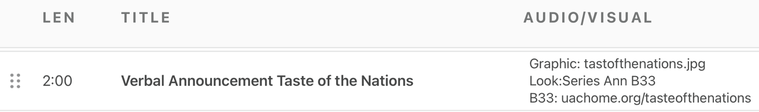

Start by adding in the graphic to the slide as was previously done. You must create a presentation to make this work.

Then add the macro “Look:Series Ann B33” to that announcement slide. (It is abbreviated to Ann to keep it shorter in some of this list in which it is displayed)

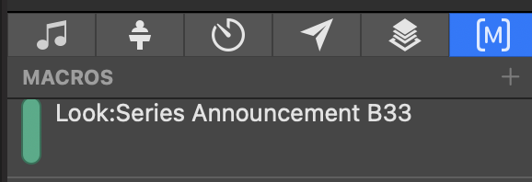

Finally, the slide should have a text box on it named “B33” and the content of that box should be “[uachome.org/tasteofthenations](http://uachome.org/tasteofthenations)”. When you finish editing the slide (edit mode), it will look like this:



And FH will look like the left and LS will look like the right.



Figure 3 Left: Front of House, Right Livestream

Keys points:

1. The text box has a name of B33 – (this is important because, under the hood, the name needs to match the name in the theme)
2. The text box (in edit mode) is below the actual graphic. This is because this text is in addition to what we want to see on FH, and we want that text visible on LS only.
3. The font size doesn’t really matter as the formatting will be controlled by the theme. I made it large just so it is easy to see here.
4. It is important for the ProPresenter Tech to also think of what is next. If there is no livestream graphic for the next item, you’ll want to turn it off using the macro “Look:Off”. This may not be explicitly said.

## Video Tech

The Video Techs also need to pay attention to the instructions in PCO as that will inform them about the positioning of the graphics.

The Video Techs need to frame up the camera image so that they have space surrounding the subject of that image to accommodate the additional text(s) (ex. the Bottom 33%).

Ensure that the Upstream key is turned on.

## General Notes

B33 is likely to be the most common position. But we have the flexibility to lay things out in other ways, too. They could be used in combination.

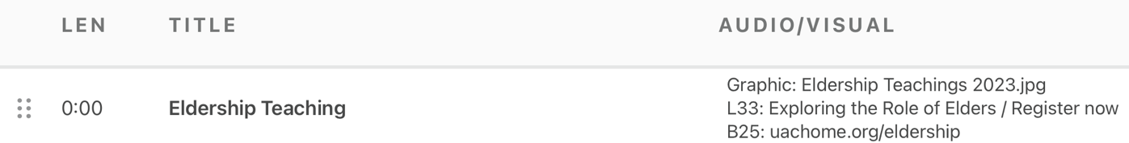

In this example we have two text boxes, one which will appear on the left 33% and the other on the bottom 25%. The intent is to have text on both the left side and the bottom.



Figure 4 Front of House

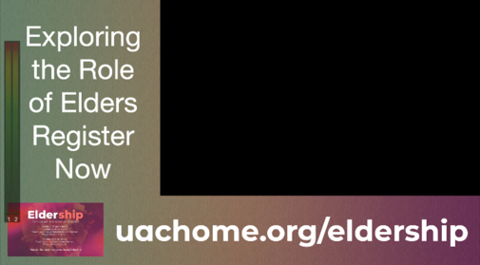

Figure 5 LiveStream

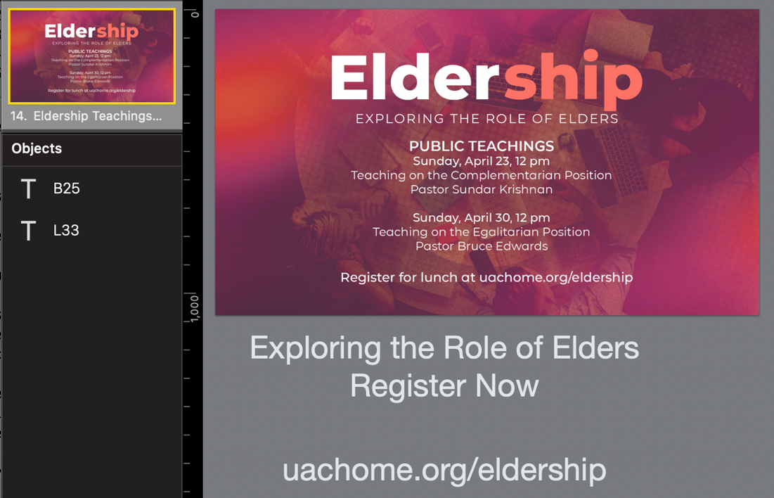

Figure 6 Edit View

The “Look” picks the theme for the livestream, and that theme defines the text formatting and all the graphic elements. For regular events, the theme will use the series graphics. However, a theme can be specially crafted for a big event like a watch party (see below).

For the video Tech, you will know that there will be content from ProPresenter on the left 33% of the Screen, and on the bottom 25% of the screen.

# Under the Hood

## Setup at the Video Mixer

There are two things that need to be done at the ATEM:

1. Turn on the upstream key
2. Ensure that the upstream Key settings (via the software) look like this
   1. In the upstream key section
   2. Go to the Luma Tab
   3. Set the Key Source and Fill Source to PP_Key and PP_Fill Respectively.
   4. Ensure that the mark and flying key are off

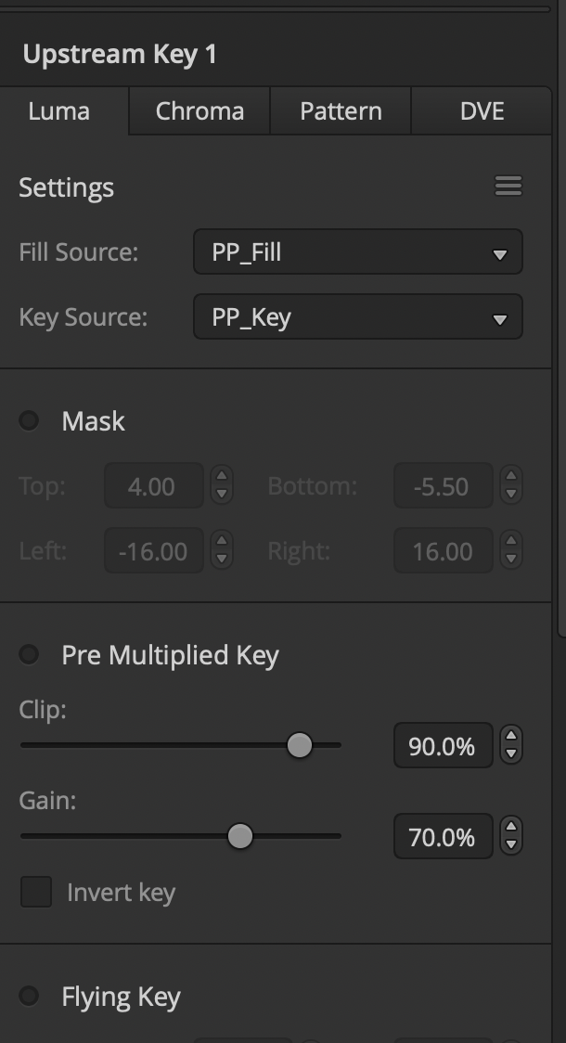

## ProPresenter Setup

The Layout of the Livestream content is determined by the “Theme” assigned to the output (not the theme applied to the slide). The assignment of the theme to the output is determined by the “Look”. And the look used it determined by the “Audience Look” on the actual slide. This “Audience Look” assignment will usually be handled by a macro with the prefix of “Look:”.

The next section goes through the creation of a custom theme, and look for a special announcement and describes these connections in more detail.

## An Example of a Custom Setup

Suppose the Maple Leafs are in the Stanley cup playoffs (we can dream!), and we are going to host a watch party for the games. We want a special announcement for this event. The item on PCO would like this:

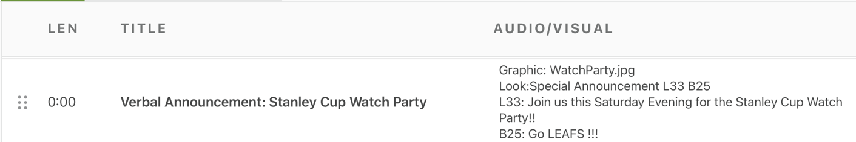

The result is to look like this (WatchParty.jpg on the left, and the LS layout on the right:



Figure 7 Front of House



Figure 8 LiveStream

We will create a new presentation for this, add a slide and drop the WatchParty.jpg image on it. Then we would edit that slide and add text boxes named B25 and L33 to it. Drag them both below the image and set the text box contents as directed. It will look like this:

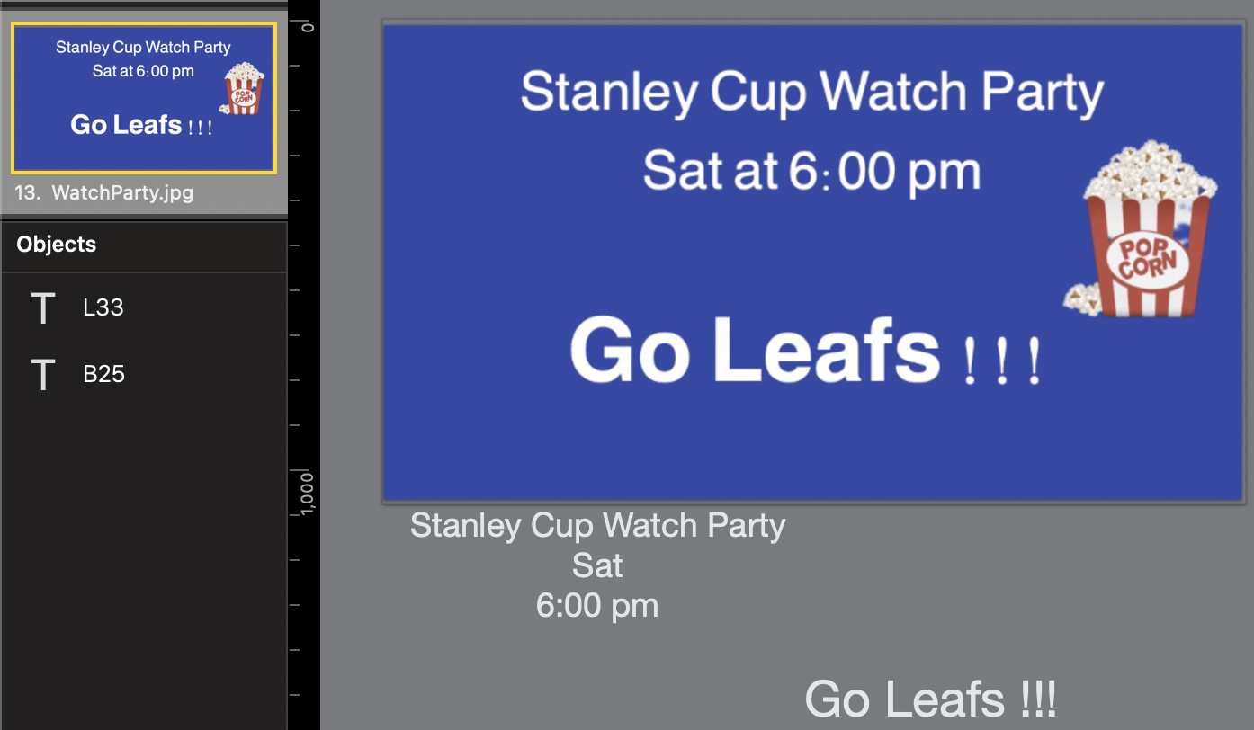

Figure 9 Edit View

(The text font for the B25 and L33 was set to be large so it could be read in the tutorial the actual size doesn’t matter, as we will see later.

Now we need to create a theme for the livestream layout. The result would look like this. The names of the text boxes on the presentation slide need to match the text boxes on the theme and ProPresenter will fill in the values by matching the names.

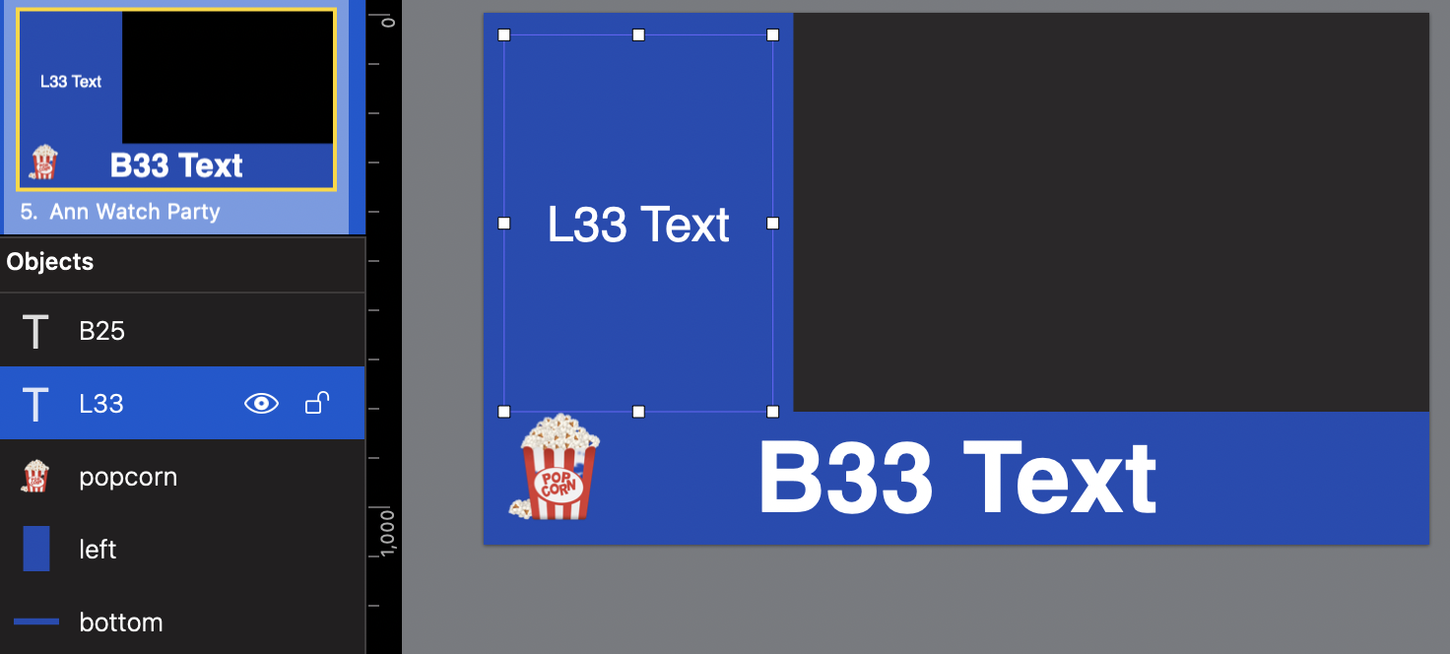

Next, we need to create a “Look”, which will tell ProPresenter which theme to use.

“Edit Looks...” is found on the “Screens” menu. Create a new "Look” and give it a meaningful name, in this example I called it “Ann WatchParty”. Each output has a column, you want to select the “Atem FillKey” column. You then select the theme to associate with that look on the presentation line. See the yellow boxes.

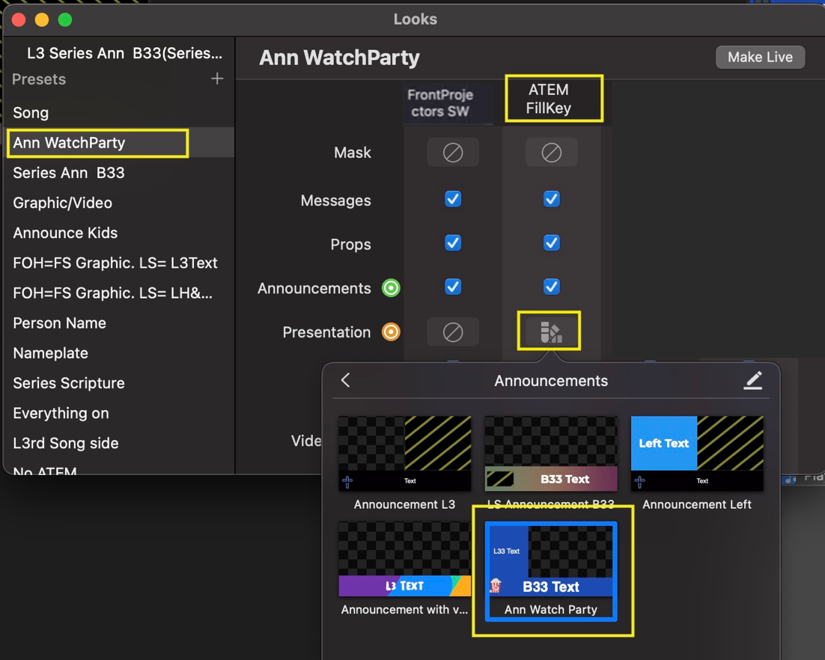

We are almost done. The last step is to add a look change to the slide.

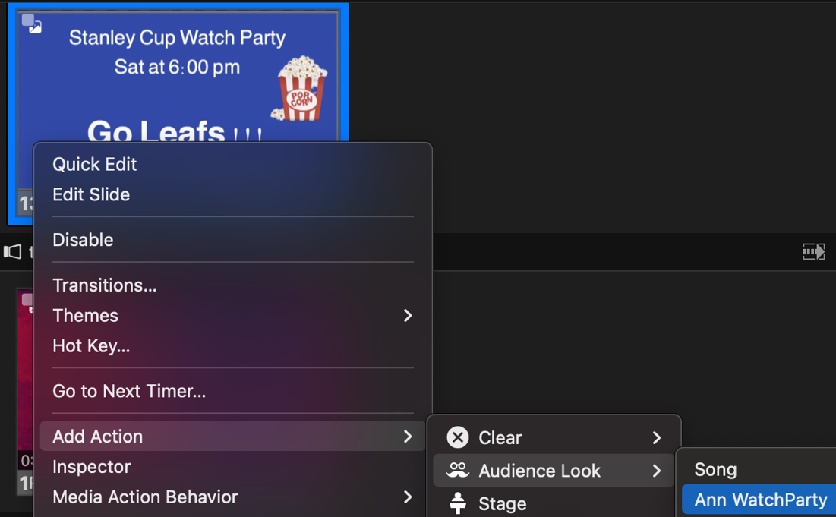

If this is a look that will need to be setup often, then you can create a macro that does it.

## List of Standard Macros (and Looks)

When looks need to be applied often, using a macro for this is convenient. We have created a collection of macros for commonly used Looks

|  |  |  |
| --- | --- | --- |
| Name | Purpose | Text Box Details |
| Look:Off | No graphics sent to ATEM | None |
| Look:Song | Lyric formatted for a Song | Not relevant |
| Look:Full | ProPresenter  will fill the Full Image on the ATEM | Not relevant |
| Look:Series Name | Lower third for a person’s Name | Name |
| Look:Series Name+Title | Lower third for a person’s Name and Title | Name  Title |
| Look:Series Scripture | Lower third formatting for scripture including verse reference sitting above and to the left | TODO/Terry – need to look. Needs to be in -sync with the bibles module |
| Look:Series Ann B33 | Announcement with series background on the bottom 33% of the image | B33 |
| Look:Series Ann B25 L33 | Announcement with series background on the bottom 25% and Left 33% of the image. Each with a text box. | B25  L33 |